**What is URL and TYPES of URL?**

* URL stands for **uniform resource locator**
* It is used to indicate the location of a web resource to access the web pages.
* URL is **a locator or address that points to a specific website address**.

**A**[**URL**](https://www.javatpoint.com/url-full-form)**(Uniform Resource Locator) contains the information, which is as follows:**

* + - * The port number on the server, which is optional.
      * It contains a protocol that is used to access the resource.
      * The location of the server
      * A fragment identifier
      * In the directory structure of the server, it contains the location of the resource.

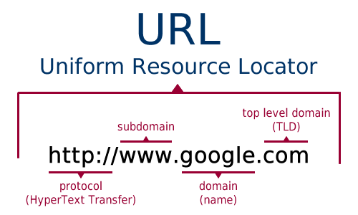

Types of URL:

1. Absolute URL

An absolute URL is as the name refers a complete address of the destination proposed to reach.

For example the URL <https://www.mywebpage/resources/xyz-content>  is the absolute URL pointing to [www.mywebpage.com](http://www.mywebpage.com/) and leads to the” xyz-content” which is a part of” resources”.

1. Relative URL

A relative URL is **a URL that only includes the path**. The path is everything that comes after the domain, including the directory and slug